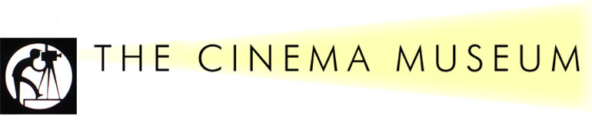
The Next Members’ Event: Saturday 14th March, 2015

2 Dugard Way (off Renfrew Road), London SE11 4TH
Rattigan on Screen
2.00 p.m. a tour of the Museum and film screening

London’s Cinema Museum is devoted to keeping alive the spirit of cinema. Set in historic surroundings in the former Lambeth Workhouse, Kennington, close to the Elephant & Castle, the Cinema Museum houses a unique collection of artefacts, memorabilia and equipment that preserves the history and grandeur of cinema from the 1890s to the present day, including items relating to former Workhouse inmate, Charlie Chaplin. Our visit will include a tour of the Museum collection, followed by screening of a Rattigan-related film (either an adaptation of one of his plays or one of his screenplays) with a ‘supporting programme’ of material from the Museum’s collection. Tickets cost £12 to include refreshments.

To add a sense of audience participation, please vote for your preferences of film from the following selection:
Movies on 16mm film: The Browning Version. Movies on DVD: The Deep Blue Sea (1955), Separate Tables (1958), The Way to the Stars, Bond Street, The Yellow Rolls Royce, The Sound Barrier, The Browning Version, The Man Who Loved Redheads. TV productions: The Winslow Boy (1977), The Browning Version (1985), Adventure Story (1961), Heart to Heart (1962), Separate Tables (1970), French Without Tears (1976). We can’t guarantee to have every film available on the day, but these are the ones we hope to be able to choose from.

and an optional pre-event
Lunch at Brasserie Toulouse Lautrec
12 noon. 140 Newington Butts, Kennington, London SE11 4RM
Head Chef: Florent Regent
Brasserie Toulouse Lautrec is a most attractive pub/restaurant in the traditional French country style. The Society has reserved a private room on the 1st floor and lunches start from £5 or £10 a head or a more haute cuisine lunch menu of two courses for £22, with an additional 12.5% service charge. House wines are £17.50. Menus will be sent to members nearer the time. (The restaurant is 5 minutes walk from the Cinema Museum).
……………………………………………………………………………………………………..……
B O O K I N G F O R M
Event | No. of places | Cost
Tour of the Cinema Museum and Film Screening |  | £12 per ticket
Optional Lunch at the Brasserie Toulouse Lautrec |  | Pay on the day, from £5 for one course.
TOTAL: I enclose a cheque for
Name - please also state name(s) of your guest(s)

Address

Telephone Number Email

Film Preference: 1) 2)
Please make your cheque payable to “The Terence Rattigan Society” and return it to arrive NO LATER THAN END JANUARY, 2015 to Mrs Barbara Longford, 7 Argyll Mansions, Hammersmith Road, London W14 8QG
Tel: 020 7603 7399 barbara.longford@ntlworld.com
(Receipt of all booking forms will be acknowledged and cheques will not be cashed until February 2015.)

