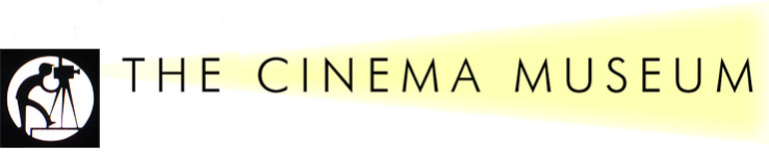
Christmas Event:
Saturday 3rd December, 2016

2 Dugard Way (off Renfrew Road), London SE11 4TH
Rattigan on Screen
2.30 p.m.. The Cinema Museum
Guest of Honour: Liz Fraser

London’s Cinema Museum is devoted to keeping alive the spirit of cinema. Set in historic surroundings in the former Lambeth Workhouse, Kennington, close to the Elephant & Castle, the Cinema Museum houses a unique collection of artefacts, memorabilia and equipment that preserves the history and grandeur of cinema from the 1890s to the present day, including items relating to former Workhouse inmate, Charlie Chaplin.

Clive Montellier will open the event by interviewing our Guest of Honour, Liz Fraser. Well known for her many appearances in British films, Liz Fraser has a number of connections with the world of Rattigan. In 1970, she appeared opposite Telly Savalas in a TV production of Man and Boy, and she has also appeared on stage in Flarepath. In addition, one of her early cameo roles was in Wonderful Things, opposite our President in her film debut.

Our featured film for the day will be ‘The Sound Barrier’ released in 1952 with screenplay by Terence Rattigan. Epitomising the groundbreaking work of the British aviation industry, this was the film highlighted by Simon Heffer in his address to the Birthday Dinner as one of the shining examples of post-War British film-making. Our day will also include a tour of the museum for those who have not already had this experience.

Tickets cost £12 to include refreshments.

and an optional pre-event
Lunch at Brasserie Toulouse Lautrec
12 noon. 140 Newington Butts, Kennington, London SE11 4RM
Head Chef: Florent Regent
Brasserie Toulouse Lautrec is a most attractive pub/restaurant in the traditional French country style. The Society has reserved a private room on the 1st floor and lunches are very reasonably priced, starters cost from £5 or £6 and £10 - £15 main course. A 12.5 % service charge is added to bills. Menus will be sent out nearer the time, so that members can pre-order their meal. House wines are £19 per bottle. (The restaurant is 5 minutes walk from the Cinema Museum).
……………………………………………………………………………………………………..……
B O O K I N G F O R M
Event | No. of places | Cost
Tour of the Cinema Museum and Film Screening |  | £12 per ticket
Optional Lunch at the Brasserie Toulouse Lautrec |  | PAY ON THE DAY
TOTAL: I enclose a cheque for
Name - please also state name(s) of your guest(s)

Address & e-mail:

Please make your cheque payable to “The Terence Rattigan Society” and return it to arrive NO LATER THAN END OCTOBER, 2016 to Mrs Barbara Longford, 7 Argyll Mansions, Hammersmith Road, London W14 8QG
Tel: 020 7603 7399 barbara.longford@ntlworld.com
(Receipt of all booking forms will be acknowledged.)
N.B. CHEQUES WILL NOT BE PRESENTED UNTIL NOVEMBER

