The Terence Rattigan Society

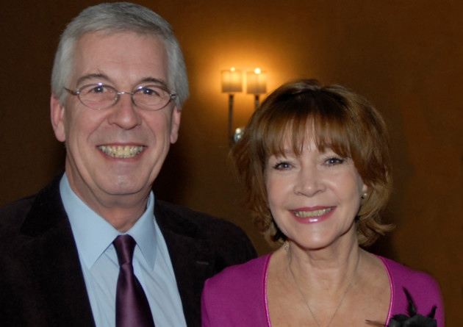

Live Online Play Reading – Heart to Heart by Terence Rattigan
Wednesday 20 January 2021 at 7pm via Zoom
In the absence of any normal events for the Society – for reasons we know only too well! – and by arrangement with Alan Brodie Representation the Society is presenting a live online reading of a lesser-known play by Terence Rattigan and we hope members will wish to ‘attend’ the reading by requesting a special link (see below).
Heart to Heart is an original play for BBC television, first broadcast in 1962, starring Ralph Richardson, Kenneth More, Peter Sallis, Jean Marsh and Wendy Craig. It has been adapted for an online reading and is inspired by John Freeman’s famous TV interview programme, Face to Face. As far as we know, this may be the first outing for this play since the 1960s. The readers will include member Judy Buxton and her husband Jeffrey Holland (pictured); the full cast list is below.
The play revolves around a newly appointed cabinet minister with a dubious past, Sir Stanley Johnson, who is to be interviewed on live television. The interviewer, David Mann, is determined to expose Sir Stanley as a phoney, but this will put his own career at risk, especially since he is undergoing a personal crisis and has taken rather liberally to the bottle. Roger Mills has written an article in the January newsletter about the original TV production.
The reading will take place via Zoom, hosted by our Secretary, Martin Amherst Lock. If you wish to attend, please email Martin at this address: mramherstlock@gmail.com. He will then send you a link to the event. You should be able to simply click on this link from 6.30pm onwards and you will be admitted to the ‘meeting’ which will begin promptly at 7.00pm on 20 January. The estimated running time is 80 minutes.
For those unfamiliar with Zoom, please do not be deterred! All you need is a laptop or tablet (or smart phone) which has a camera and sound facility (most do these days, as standard). The procedure will be explained at the start of the reading.
We very much hope to welcome you to this first ever live online Society event!
Phill Ward
Events Secretary

Heart to Heart
by Terence Rattigan

Introduced by
Geoffrey Wansell

Director
Michael Gaunt

Narrator
Martin Amherst Lock

DAVID MANN
Giles Cole

PEGGY MANN
Judy Buxton

FRANK GODSELL
Michael Gaunt

JESSIE WESTON
Amanda Weston

SIR STANLEY JOHNSON
Jeffrey Holland

MR STOCKTON
Leslie Du Cane

MISS KNOTT
Alison Du Cane

