THE TERENCE RATTIGAN SOCIETY

GUSTAV MAHLER AT THE ROYAL ALBERT HALL

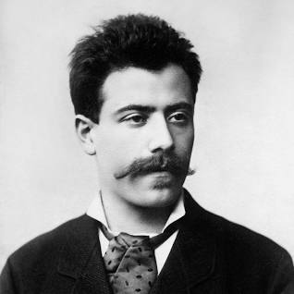

THURSDAY 27 APRIL 2023
Riotous, hallucinatory, extraordinary: Mahler’s Third Symphony knows no bounds, taking us from the smallest flower to the mystery of divine love. Mahler said that the composer of symphonies must ‘embrace the world’. That utterance finds its fullest expression in this, his longest, perhaps most moving, symphony. In six movements Mahler charts the evolution of nature and mankind. The elemental power of summer is set against the delicacy of the natural world. And the dark night of the soul is broken by the sounds of angels and a ‘great summons’ to love more deeply than ever before. A symphony filled with music of life-enhancing physicality and breath-taking melodic beauty, it is a story of a breadth and ambition which only a true original such as Mahler could have dreamed of let alone written.

3.30pm: Tour of the Royal Albert Hall. The iconic South Kensington rotunda has many stories to tell since opening in 1870. One of the RAH’s staff will take us on a tour of this magnificent space.

5.30pm: Dinner: two courses in Café Verdi, the RAH’s in-house restaurant ideally positioned just a few yards from your seat for the evening’s concert. A prix fixe menu will be circulated later; the price does not include drinks.

7.30pm: Concert: Mahler Symphony No.3 in D minor
Vasily Petrenko: conductor; Hanna Hipp: mezzo-soprano; Philharmonia Chorus; Tiffin Boys' Choir; Royal Philharmonic Orchestra

Bookings and payment, please, by Friday 24 March. Note: you may book the tour and dinner only, or the concert only, or the tour and dinner and concert. Please indicate requirements as follows:
✂ ……………………………………………………………………………………………………..……

B O O K I N G F O R M
 | Amount | Number required
RAH Tour & Dinner: Café Verdi | £40.50
Concert ticket: Royal Philharmonic | £35.00
I have made a bank transfer for:  Lloyds TSB Chelsea Branch  Account Number: 22820768  Sort Code: 30-64-72  Important: include RAH as reference | £  Please confirm bank transfer to phillward@me.com.
I enclose a cheque for:  Payable to:  The Terence Rattigan Society  and mail to:  Phill Ward, TRS Events Manager  114 Sandmere Road  London SW4 7QH | £  Please confirm dispatch of cheque to phillward@me.com.

Please make your booking and make transfer/send cheque (as appropriate) by 24 March (we are holding ticket reservation only until that date) to: Phill Ward, 114 Sandmere Road, London SW4 7QH

